Computer Sciences Corporation
Financial Services Group

Future Generali Life Co., Ltd.

Technical Specifications

Description: | Sample Doc
Reference No:
Version: | 1.0
Date: | Submitted By  Siva Sagari Allu

Letter Generation :- In this first we have to find from which transaction code the letter was triggered. If we find the transaction code then search in table TR384. If not Need to create the transaction code for which we need to trigger the letter.
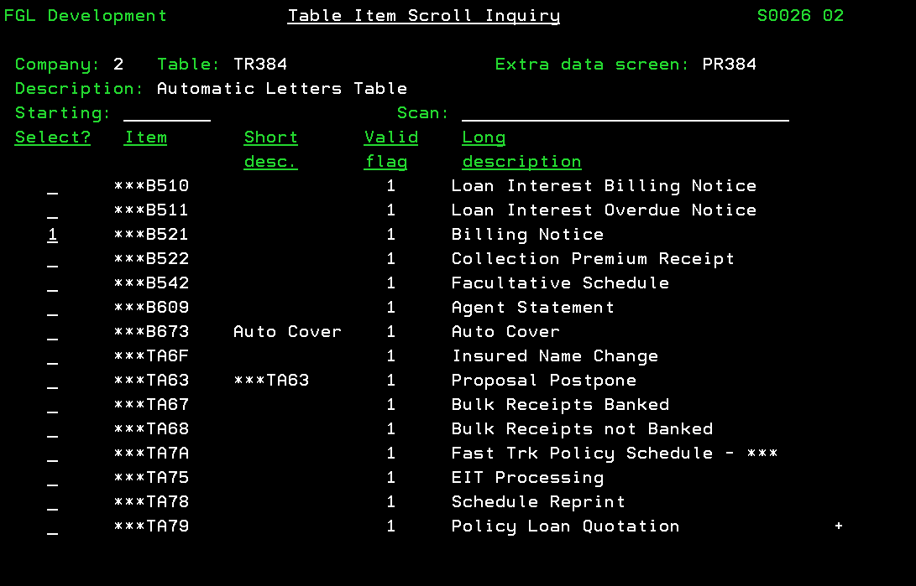
Based on the Transaction code in TR384 we can get the letter group which is for to trigger the list of letters.
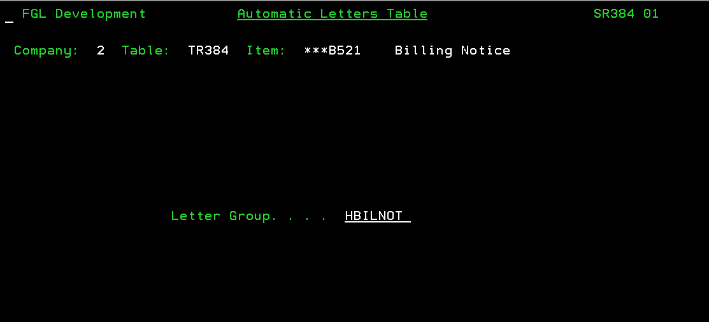
For Example: Billing Notice letter was triggered from the transaction code B521 which is contract billing transaction code.
Based on this letter group in item TR384, we have to create one item in TR383 for letter group. It is used to trigger the list of letter with the same item in TR384.
For Example: Item in TR383
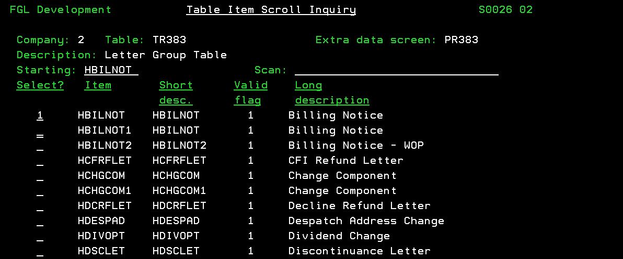

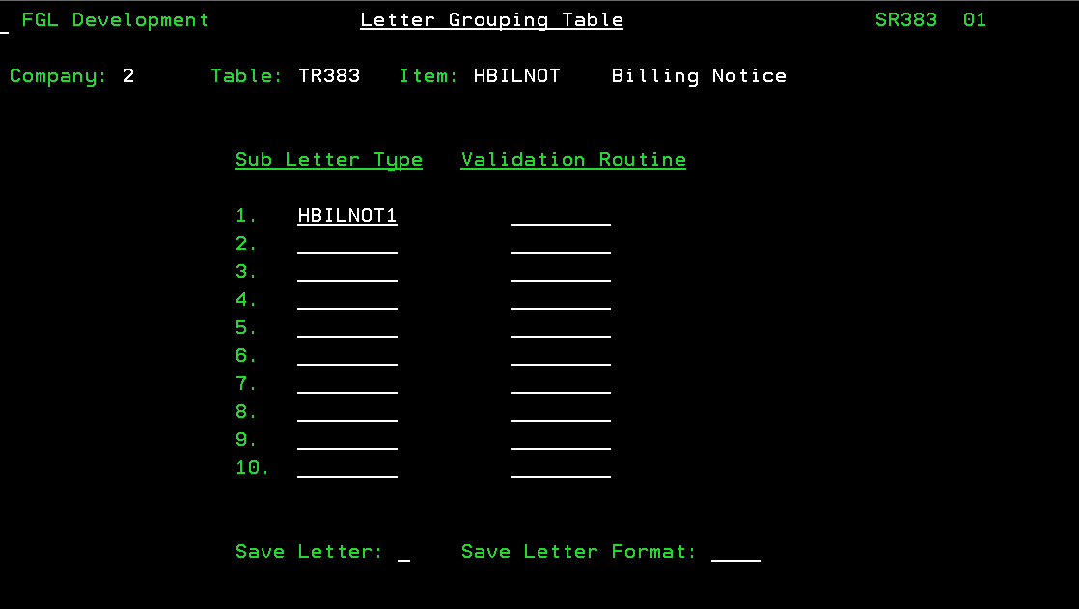
Based on the letter group in TR384 there is one item in T2634. In T2634 the item contains the Item field ID code and format of the letter and path. The field id code is used to define an item in T2635.
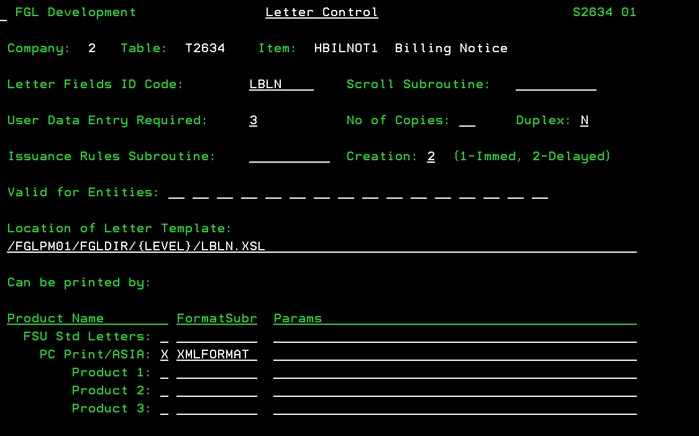
-Letter Field ID: based on the ID we can find the related fields for the letter in T2635.
T2635: The list of required fields is defined in table T2635. These are the fields we can display in XML letter. 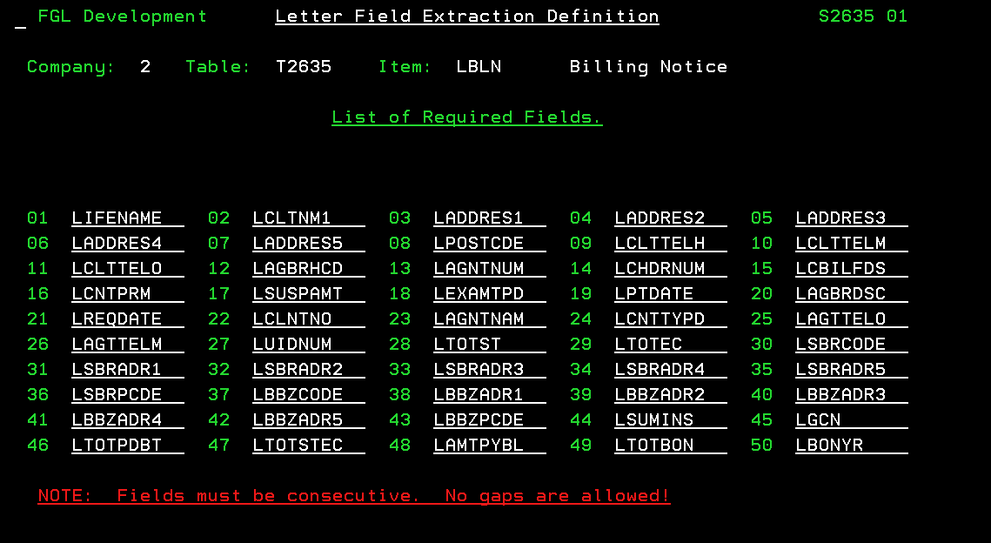
The fields in the item in T2635 are defined in T2636. And each field is an item in T2636 and every item contains one subroutine which is used to display the values in XML letter.
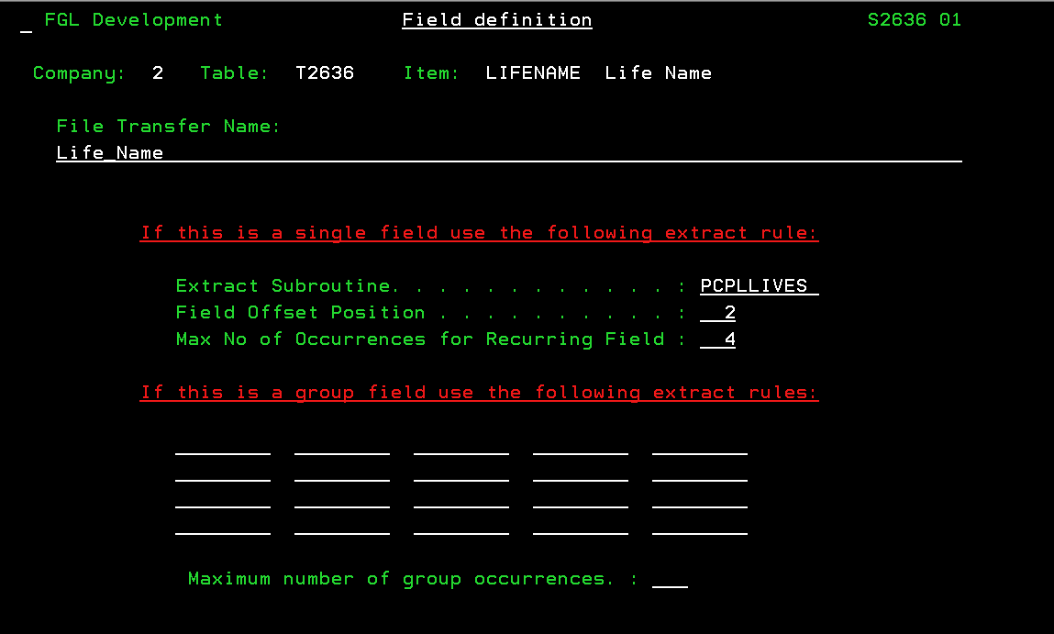
How to trigger the letter:-D -> System Administration -> XML Printing and then enter contract number
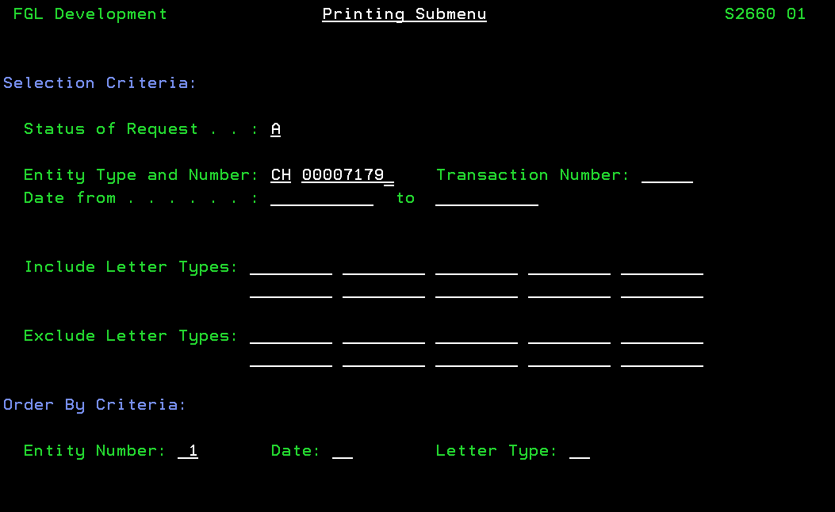
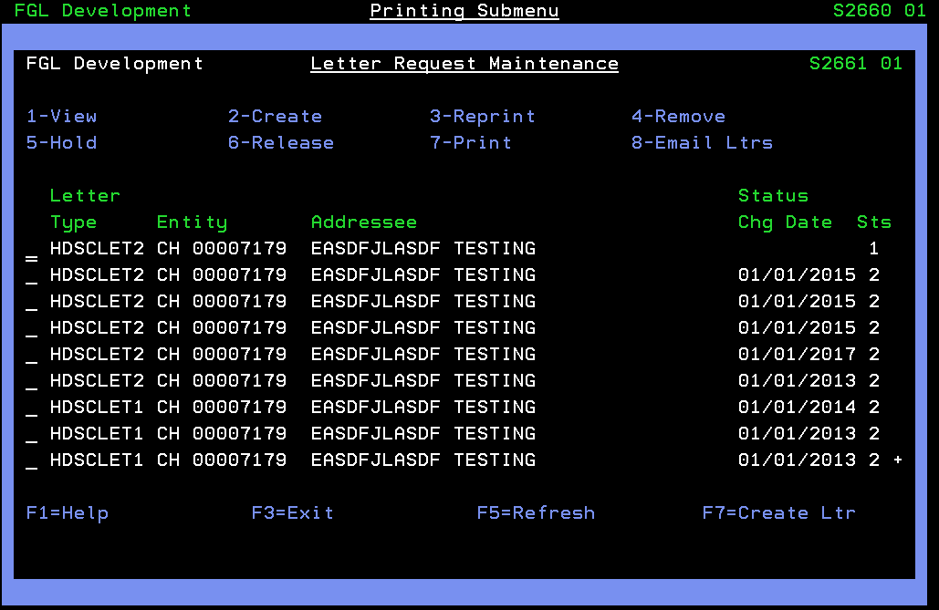
The status of the letter is 2 if we want to print that letter then take the action ‘3’ and enter. It will recreate the letter with status 1. Now take action ‘2’.
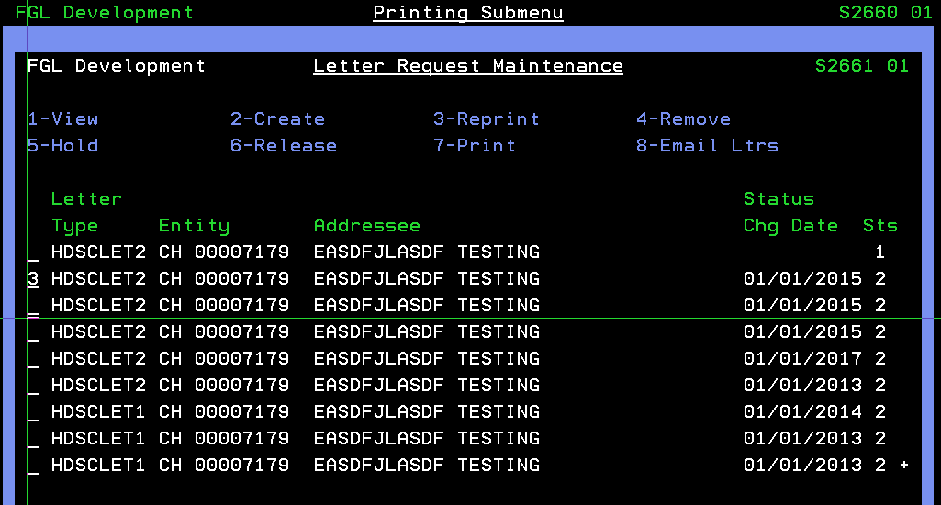
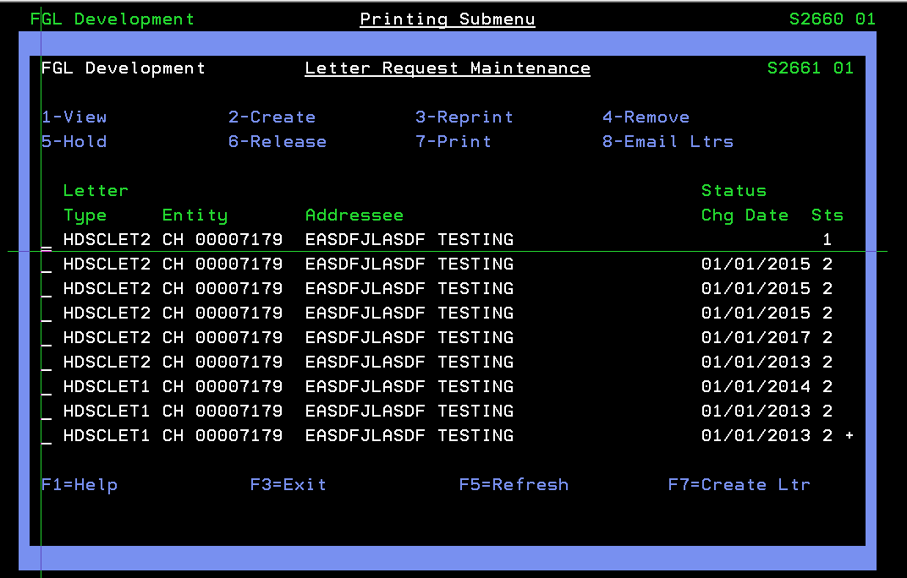
If the status of the letter is 1 then directly we can take the option ‘2’.
Testing of Letter Generated:-
There are two ways to check the letters.
- Directly open the folder by giving the IP address and in Root folder.
Path of the XML letter
Run - > \\10.1.41.62 - > Enter Credentials -> Root Folder - > Print XML -> fgldev/fglact -> select the year of triggered -> search your letter by application name and contract number in this folder.
We can open the letter in notepad and check the fields in the letter.

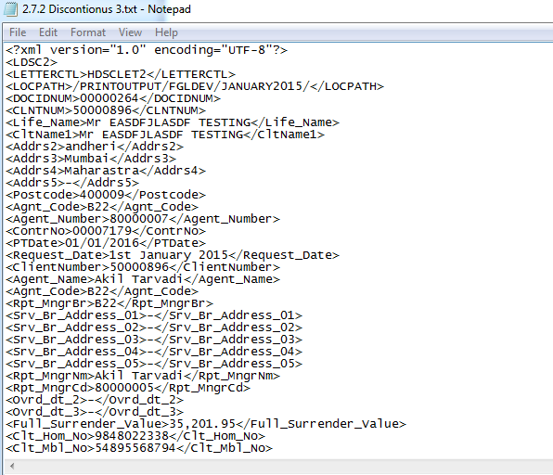
- Another way to check the XML letters by command prompt
WRKLNK - > PrintXML select by option 5 -> fgldev select by option 5 -> Select the Year -> select your letter by contract number.
In this we can see in normal screen.
Example of XML letters:
